**SMART WATER MANAGEMENT SYSTEM**

**Problem statement:**

* In the face of accelerating urbanization and growing environmental concerns, the effective management of our water resources has become an imperative for sustainable living. Access to clean, reliable water is fundamental to human well-being and economic prosperity. However, the challenges posed by increasing demand, deteriorating infrastructure, and climate variability call for innovative solutions in the realm of smart water management SMART WATER MANAGEMENT

**Problem definition:**

* Smart water management refers to the use of advanced technology and data-driven approaches to monitor, control, and optimize the distribution and consumption of water resources. The problem can be defined as follows:
* “Smart water management is the challenge of efficiently and sustainably managing water resources by integrating sensor technology, data analytics, and automation to monitor water quality, detect leaks, reduce wastage, and ensure equitable distribution, all while considering environmental and economic factors.”
* This problem encompasses various aspects, including water quality monitoring, leak detection, demand forecasting, equitable distribution, and environmental sustainability. Solutions often involve the use of IoT sensors, data analytics, and decision support systems to address these challenges.

**Introduction:**

* Smart water management is a comprehensive approach that leverages technology, data, and innovative strategies to optimize the use of water resources, enhance water quality, and improve overall efficiency in water-related processes. It encompasses a wide range of solutions, such as IoT sensors, data analytics, and automation, to monitor, control, and optimize water supply, distribution, and treatment systems. By integrating these technologies, smart water management aims to address the growing challenges of water scarcity, aging infrastructure, and environmental sustainability while ensuring reliable access to clean water for communities and industries.

**LIRATURE SURVEY**

* Creating a literature survey for a smart water management project involves researching and summarizing relevant academic papers, reports, and articles to inform your project. Here’s an outline of what you can include in your literature survey:

**1. Introduction:**

* Briefly introduce the concept of smart water management and its significance.
* Explain the purpose of the literature survey in the context of your project.

**2. Water Management Challenges:**

* Discuss the challenges related to water scarcity, aging infrastructure, and environmental concerns.
* Reference works that highlight the pressing issues in water management.

**3. IoT and Sensor Technologies:**

* Explore studies on the use of IoT sensors for water quality monitoring and leak detection.
* Summarize key findings and insights from relevant research.

**4. Data Analytics and Decision Support:**

* Highlight research on data analytics in water management and decision support systems.
* Discuss how data-driven approaches can improve water resource management.

**5. Water Distribution and Leak Detection:**

* Present research on smart water distribution systems and methods for leak detection.
* Discuss the impact of these technologies on reducing water losses.

**6. Smart Metering and Customer Engagement:**

* Summarize studies on smart water metering and customer engagement strategies.
* Explore how these technologies can enhance water conservation and customer satisfaction.

**7. Water Quality Monitoring and Treatment:**

* Discuss research on smart systems for water quality monitoring and treatment.
* Explain how these technologies contribute to maintaining water quality standards.

**8. Sustainability and Environmental Impact:**

* Highlight works discussing the sustainability aspects of smart water management.
* Examine research on the environmental impacts and benefits of these systems.

**9. Case Studies and Best Practices:**

* Include examples of successful smart water management implementations.
* Analyze case studies to extract lessons and best practices.

**10. Challenges and Future Directions:**

* Discuss the challenges and limitations of current smart water management solutions.
* Present ideas and research on potential future developments in the field.

**11. Conclusion:**

* Summarize the key findings from your literature survey.
* Emphasize the relevance of the surveyed literature to your project.

Remember to cite the sources properly and provide a clear and structured overview of the existing knowledge in the field of smart water management to support your project’s goals and objectives.

**DESIGN THINKING**

**1.Technology and Innovation:**

* We plan to use sensors and data analytics to monitor water usage and detect leaks in the water distribution network

**2.Data Analysis:**

* Utilize data analytics and machine learning algorithms to process the collected data. Identify patterns, anomalies, and areas for improvement. Predictive analytics can help forecast water demand.

**3.Monitor:**

* Implement sensors and data collection tools to monitor water usage, quality, and system performance in real-time.

**3.Automation:**

* Implement automated control systems that can adjust water distribution based on demand and system conditions. This can include the use of smart valves and pumps.

**4.Water Quality Monitoring:**

* Continuously monitor water quality parameters to ensure safe drinking water and environmental compliance.

**5.Environmental and Social Impact:**

* Our solution will reduce water waste, lower energy consumption, and ensure equitable water.

**THE PROJECT OVERVIEW**

* The project overview: Smart water management is an approach that leverages technology and data-driven solutions to optimize the use, distribution, and conservation of water resources. It encompasses a range of strategies and technologies aimed at improving the efficiency, sustainability, and quality of water-related processes. Here's an overview of smart water management:

**1.Water Monitoring and Sensing:**

* Smart water management systems use sensors and data collection devices to monitor water quality, consumption, and infrastructure conditions in real-time.

**2.Data Analytics and Insights:**

* Advanced analytics and machine learning algorithms process the collected data to provide valuable insights, allowing for better decision-making and predictive maintenance.

**3.Leak Detection and Prevention:**

* Smart systems can detect leaks in water distribution networks promptly, reducing water loss and infrastructure damage.

**4. Demand Management:**

* Predictive analytics can help water utilities and consumers understand demand patterns and optimize water usage.

**5.Remote Valve Control:**

* Automated valves and remote control mechanisms enable quick responses to water supply and distribution issues.

**6.Water Quality Management:**

* Continuous monitoring of water quality ensures safe and reliable drinking water, with alerts for any deviations from established standards.

**7.Asset Management:**

* Asset tracking and maintenance scheduling tools help utilities manage their infrastructure efficiently, prolonging the lifespan of assets.

**8.Customer Engagement:**

* Smart water management engages consumers by providing them with information and tools to monitor and control their water usage.

**9.Environmental Impact Reduction:**

* Efforts are made to reduce the environmental impact of water management, such as minimizing energy consumption and chemical use.

**10.Sustainability Initiatives:**

* Promoting water conservation and sustainable practices is a key component of smart water management, addressing issues like drought and overuse of water resources.

**11.Integration with IoT :**

* The Internet of Things (IoT) plays a crucial role, connecting various devices and sensors to create a comprehensive network for data exchange.

**12.Big Data and Cloud Computing:**

* Large-scale data processing and storage in the cloud allow for scalable and cost-effective solutions.

**13.Regulatory Compliance:**

* Smart water management ensures compliance with water quality and environmental regulations, reducing the risk of violations.

**14.Resilience and Disaster Response:**

* Planning and technologies are in place to respond to water-related emergencies and natural disasters.

**15.Cost Reduction:**

* By improving efficiency and reducing water loss, smart water management can lead to cost savings for utilities and consumers.

**16.Public Health and Safety:**

* The focus on water quality and infrastructure maintenance safeguards public health and safety.
* Smart water management is a comprehensive and forward-thinking approach that addresses the challenges associated with water scarcity, pollution, and aging infrastructure. It helps ensure a reliable and sustainable water supply while conserving resources and protecting the environment.

**IOT DEVICE SETUP**

**Components:**

* Nodemcu board
* Template sensor
* Water flow sensor
* Ultrasonic sensor
* Arduino Uno
* LCD display &12C module
* ESP8266 Wi-Fi module
* Relay module
* Bread board
* Jumper wire

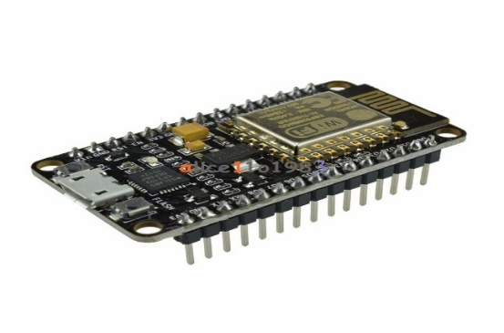**Nodemcu:**

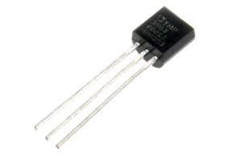Temparature sensor:

**Water flow sensor:**

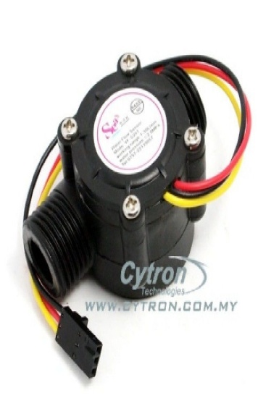

**Ultrasonic sensor :**

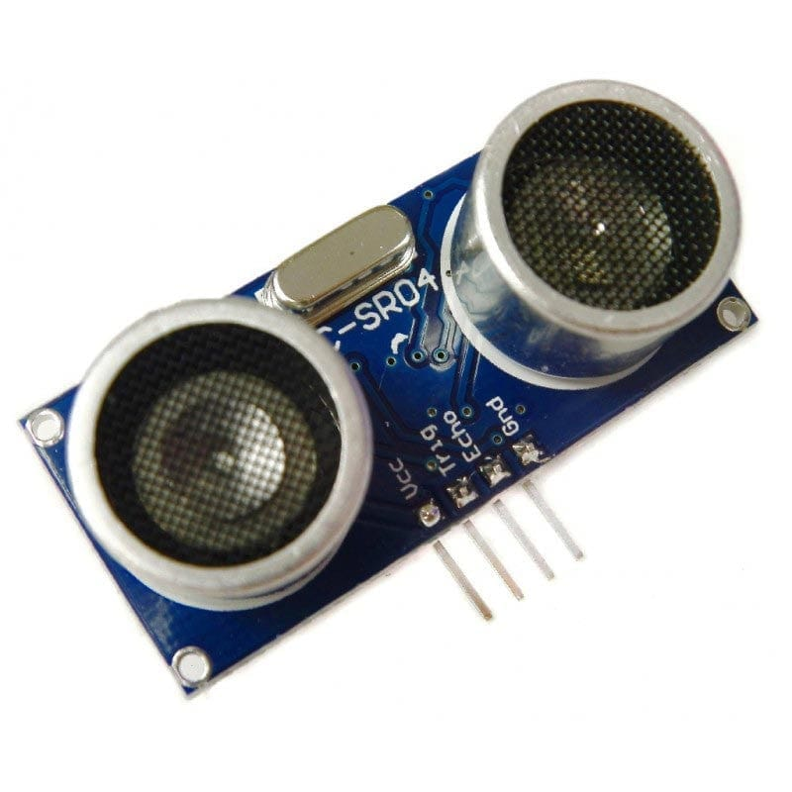

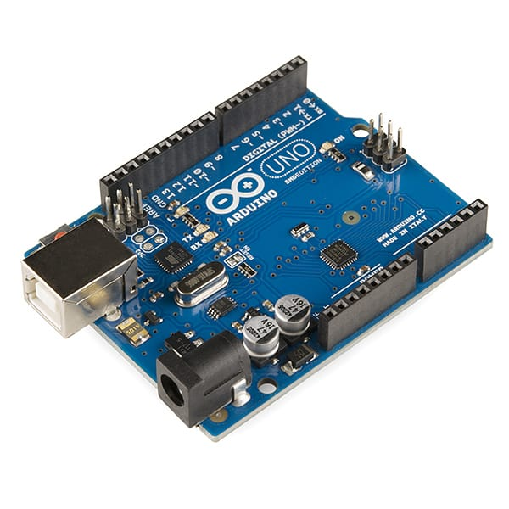**Arduino uno:**

**LCD display and 12c module:**

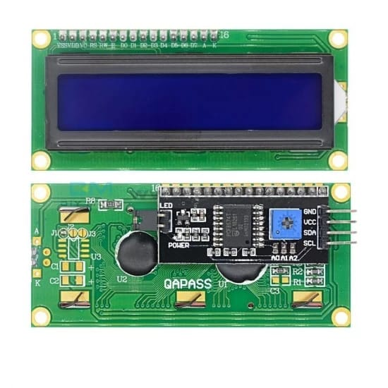

**ESP 8266 Wi fi module :**

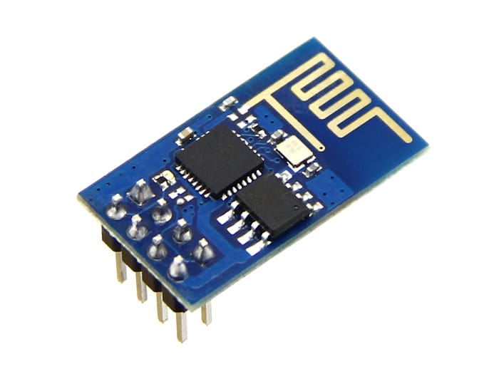

**Relay module:** 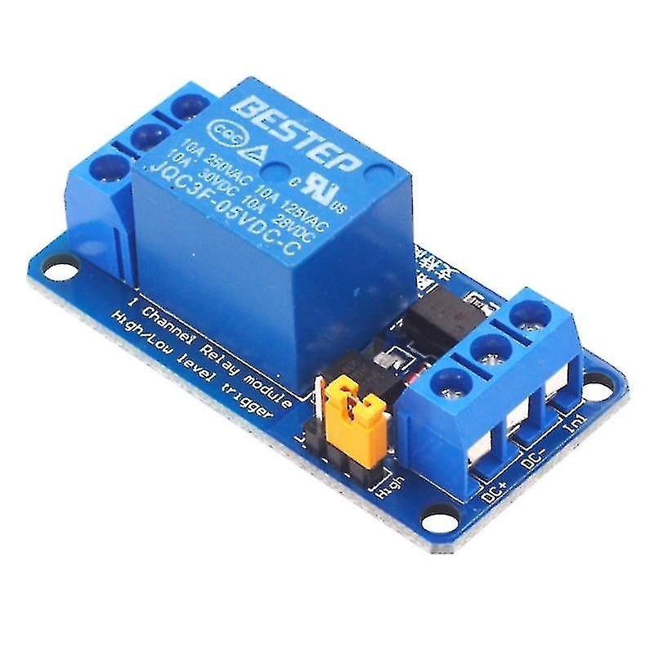

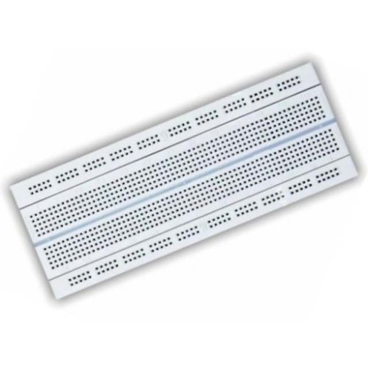**Bread board:**

**Jumper wires:**

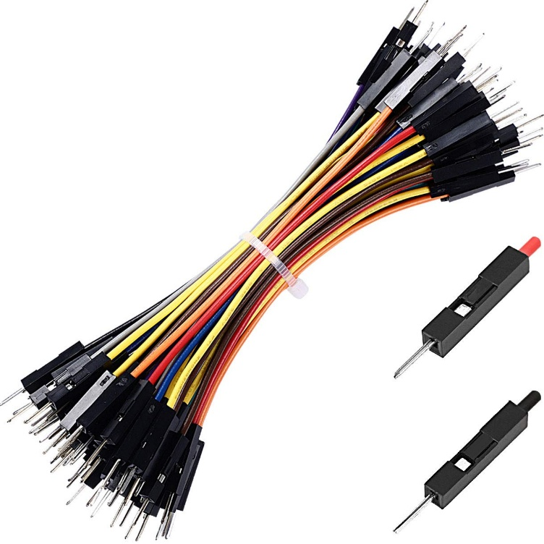

**PLATFORM DEVELOPMENT**

* Developing a platform for a smart water management project involves various components and technologies. Here’s an overview of the key steps and considerations:

**Project Definition:**

* Clearly define the objectives and scope of your smart water management project. Determine what specific aspects of water management you want to address, such as monitoring, conservation, or distribution.

**Data Collection:**

* Implement sensors and IoT devices to collect data from various water sources, such as reservoirs, pipelines, and treatment plants. This data can include water quality, quantity, and usage patterns.

**Data Transmission:**

* Set up a communication infrastructure to transmit data from the sensors to a central platform. This may involve technologies like LoRaWAN, cellular networks, or Wi-Fi.

**Data Storage:**

* Create a secure and scalable database to store the collected data. You can use cloud-based solutions or on-premises databases, depending on your project’s requirements.

**Data Analysis:**

* Develop algorithms and analytics to process and analyze the data. This can help in identifying trends, anomalies, and areas for optimization in water management.

**User Interface:**

* Build a user-friendly dashboard or web application where users, such as water utility companies or consumers, can access and visualize the data. This interface should provide insights and control over water-related parameters.

**Alerts and Automation:**

* Implement alerting mechanisms that notify relevant parties in real-time in case of issues like leaks, water quality problems, or low supply. Automation can help in responding to these issues promptly.

**Security:**

* Ensure robust security measures to protect sensitive water data and prevent unauthorized access or cyberattacks.

**Integration:**

* Integrate with existing water management systems and infrastructure to enhance interoperability and streamline operations.

**Scalability:**

* Design the platform to be scalable, so it can accommodate a growing number of sensors and data as the project expands.

**Regulatory Compliance:**

* Be aware of and adhere to local regulations and standards related to water management and data privacy.

**Maintenance and Support:**

* Plan for ongoing maintenance, updates, and support for the platform to keep it running smoothly.

**Testing and Validation:**

* Rigorously test the platform to ensure its reliability and accuracy, especially in real-world conditions.

**Data Visualization:**

* Use data visualization tools to present information in a meaningful and actionable way.

**User Training:**

* Provide training and documentation for users to effectively use the platform.
* Remember that smart water management projects are often part of larger smart city or environmental initiatives. Collaboration with relevant stakeholders, including government bodies, water utilities, and technology providers, is crucial for the success of your project.

**Source code:**

```python

Import random

# Simulate a water level sensor

Def read_water_level():

Return random.uniform(0, 100)

# Check the water level and send alerts

Def check_water_level():

Water_level = read_water_level()

If water_level < 30:

Print(“Alert: Low water level detected!”)

Elif water_level > 70:

Print(“Alert: High water level detected.”)

Else:

Print(“Water level is normal.”)

If __name__ == “__main__”:

While True:

Check_water_level()

**Here’s a basic HTML form as a starting point:**

```html

<!DOCTYPE html>

<html>

<head>

<title>Water Management System</title>

</head>

<body>

<h1>Smart Water Management System</h1>

<form action=”process_data.php” method=”post”>

<label for=”sensor”>Sensor Reading:</label>

<input type=”number” id=”sensor” name=”sensor” required><br><br>

<label for=”location”>Location:</label>

<input type=”text” id=”location” name=”location” required><br><br>

<label for=”timestamp”>Timestamp:</label>

<input type=”datetime-local” id=”timestamp” name=”timestamp” required><br><br>

<input type=”submit” value=”Submit Data”>

</form>

</body>

</html>

`

**CSS source code:**

Body {

Font-family: Arial, sans-serif;

Margin: 0;

Padding: 0;

Background-color: #f0f0f0;

}

Header {

Background-color: #333;

Color: #fff;

Text-align: center;

Padding: 20px;

}

#data-container {

Display: flex;

Justify-content: space-around;

Margin: 20px;

}

.sensor {

Background-color: #fff;

Border: 1px solid #ccc;

Padding: 20px;

Text-align: center;

Border-radius: 5px;

Box-shadow: 0 0 5px rgba(0, 0, 0, 0.2);

Max-width: 300px;

}

H2 {

Font-size: 20px;

}

P {

Font-size: 16px;

}

**Javascript :**

<!DOCTYPE html>

<html>

<head>

<title>Smart Water Management</title>

</head>

<body>

<h1>Water Sensor Data</h1>

<div id=”sensorData”></div>

<script>

// Simulated water sensor data

Const sensorData = [

{ location: “Kitchen”, reading: 50 },

{ location: “Bathroom”, reading: 40 },

{ location: “Garden”, reading: 60 },

];

// Display sensor data on the web page

Const sensorDataElement = document.getElementById(“sensorData”);

sensorDataElement.innerHTML = “<h2>Sensor Readings:</h2>”;

sensorData.forEach(data => {

sensorDataElement.innerHTML += `<p>Location: ${data.location}, Reading: ${data.reading}</p>`;

});

</script>

</body>

</html>.

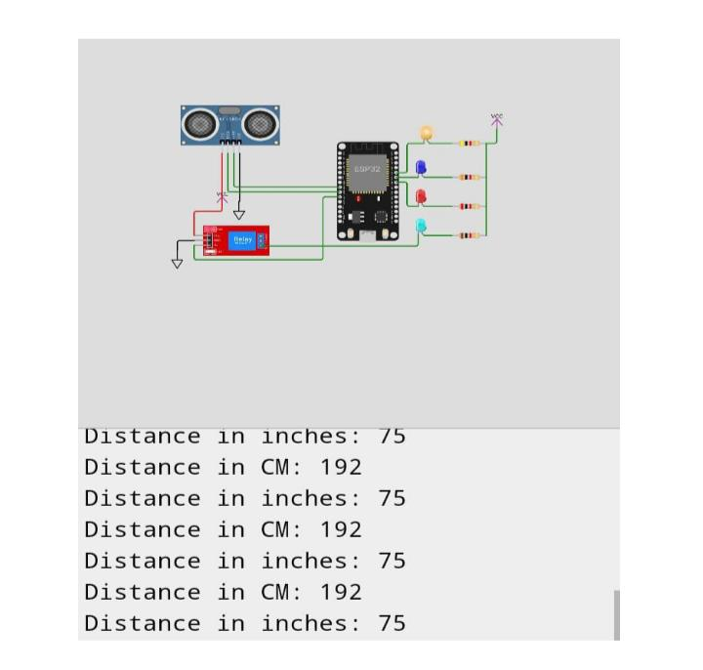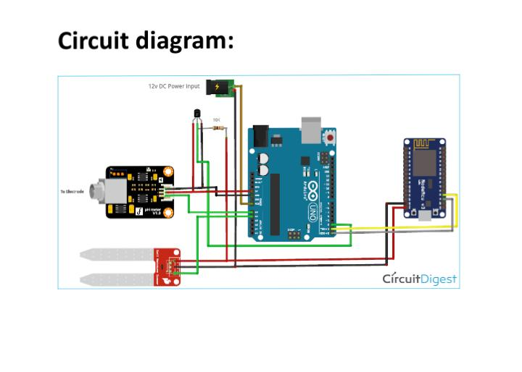

**CONCLUSION**

* In conclusion, smart water management is a comprehensive approach to monitor, analyze, and optimize water resources. It relies on a network of sensors, data analysis, and user interfaces to improve the efficiency and sustainability of water systems. By collecting real-time data, providing insights, and enabling rapid response to issues, smart water management plays a crucial role in conserving and ensuring the availability of this vital resource for various purposes. It promotes environmental sustainability, reduces waste, and enhances the resilience of water infrastructure, making it an essential component of modern water management practices.